The image shows part 1, including the module name, Tutorial and group numbers, student numbers of group participation, and name and email of students. Using HTML language to construct the table using <table> <tr><td> tags to insert data and details of objects sizes and colors using CSS.

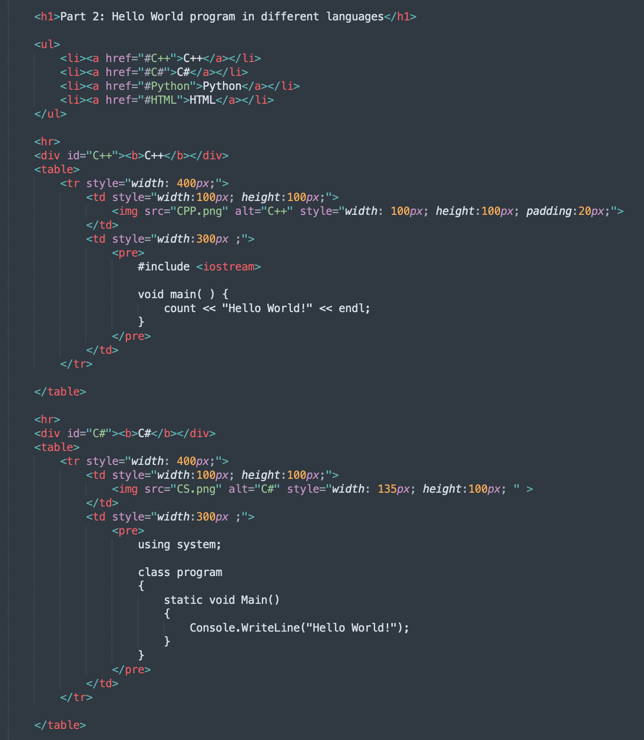

Part 2 images show 4 programming languages by their ways. Using “Hello World “to show the language that writing methods such as C++, C#, Python, and HTML. On the webpage, use <a href> tag to links to drag and down such as clicking the C# directly to reach nearly there after choosing HTML easily and clearly see the text and images from there. As shown in the image the left-hand side was the image of the language using <img src> tag and the right side was the language and code that need to use in that programming using <pre> tag. All of these are put into a table to show one by one of the programming languages.

Part 3 is university policies and services including plagiarism, academic consideration, student support advisers, and disability services using <dl><dd><dt> tags. From the web page, we insert the links for more information about plagiarism, academic consideration, student support advisers, and disability services by using <a href>tag which takes us to the information on the UOW website. Faulty of engineering and information sciences details are also provided by using the table.